ADTA-5250: Large Data Visualization – Assignment 1
(Sri Charan Bodduna – Student Id: 11661666)

Tableau Desktop installation
- I have downloaded the Tableau desktop software from tableau official website.
- I have applied to get license key for accessing Tableau on my local using my student email address.
- I received the key and I have followed the steps installed for mac version of Tableau.
- Below is the screenshot for the reference of this question.

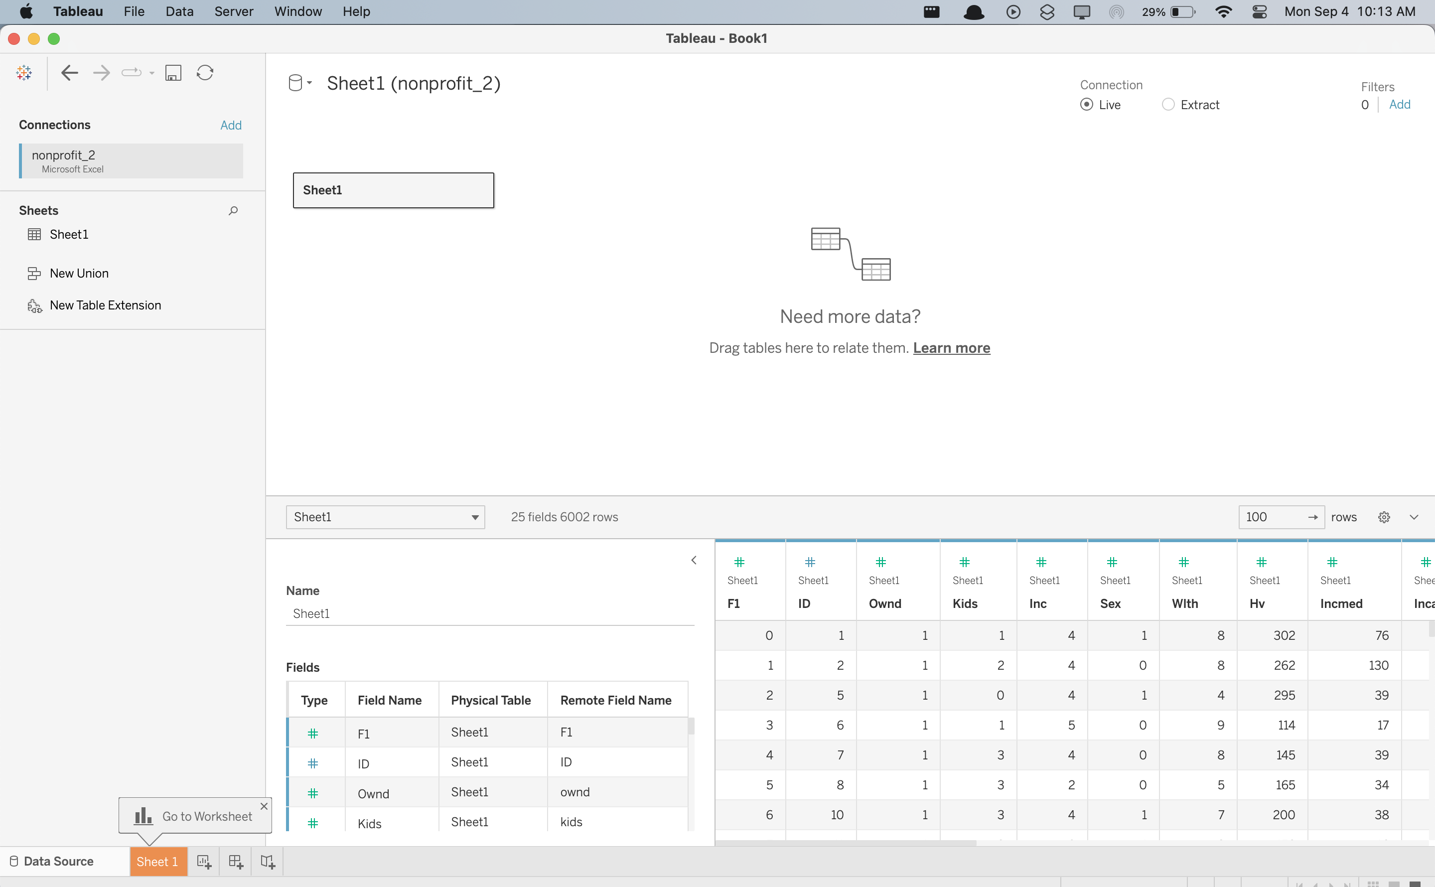
Tableau Prep Installation (Screenshot below)
- From the same official site, I have also downloaded Tableau prep installation file and I then installed software on my local computer.

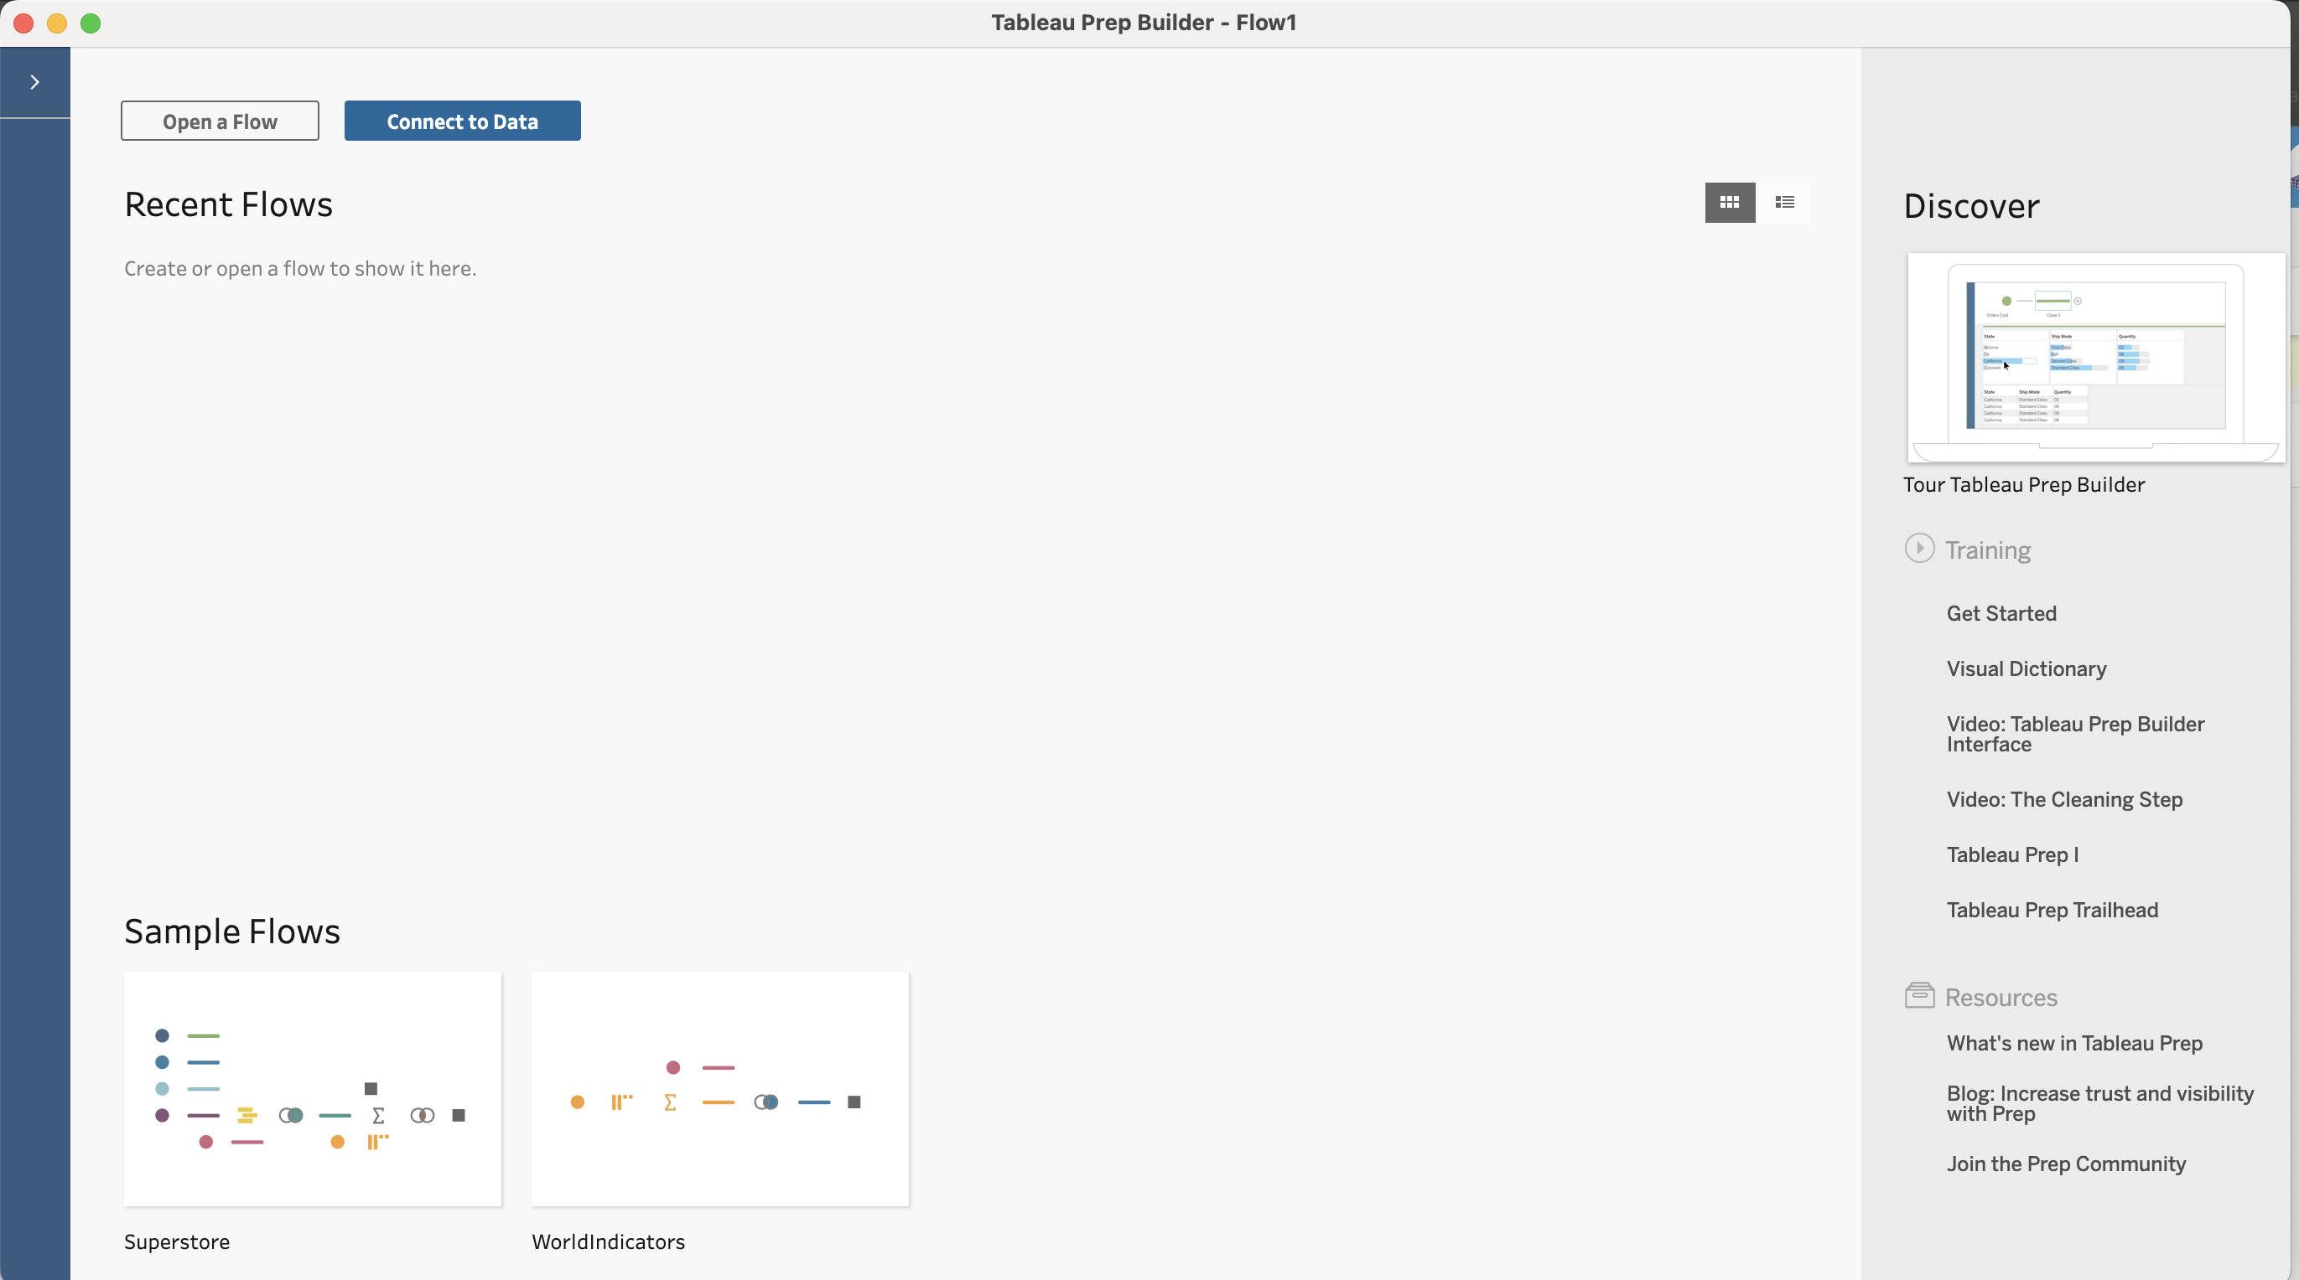

Dataset:

City of Dallas Operating Budget (Operating_Budget.csv)

Data Dictionary

Below table defines the data dictionary of the data set I have chosen.

The data is as latest as September 2nd 2023.

Column | Description | Datatype | Data Format | Dimension/  Measure | Example
BFY | Budget Fiscal Year | Text | YYYY | Dimension | 2023
FTYP | Fund Type Abbreviation | Text | XXXX | Dimension | GNFD
FUNDTYPE | Fund Type | Text | XXXX | Dimension | General Fund
APPR | Annual Portfolio Performance review | Text | XXXX | Dimension | 0001DPD
DEPARTMENT | Name of the department | Text | XXXX | Dimension | Police Department GF
SVC | Service number | Number | X.XX | Measure | 1.23
SERVICE | Service name | Text | XXXX | Dimension | Police Criminal Investigations
OBJECTGROUP | group of a | Text | XXXX | Dimension | Contractual & Other Services
BUDCURR | Current Budget | Number | NNNN | Measure | 9505798
ENCBFY | Encumbrance -  commitment of funds till date | Number | NNNN.NN | Measure | 1592800.53
EXPBFY | Expense -  Total amount spent till date | Number | NNNN.NN | Measure | 7408082.77
ENCEXP | Encumbrance + Expense  - Total Amount of funds till date | Number | NNNN.NN | Measure | 9000883.3

